Operating Systems

Lab Report 2 (4,5,6)

**SUBMITTED BY:**

**SHAHZANEER AHMED**

**REGISTRATION**

**NUMBER**

**:**

**SP21**

**-**

**BCS**

**-**

**087**

**SUBMITTED TO**

**:**

**Dr. Rubina Adnan**

**DATE**

**OF**

**SUBMISSION:**

**October 26, 2022**



Lab 4

// Task 1

Use sort and unique command to sort a file and print unique values.

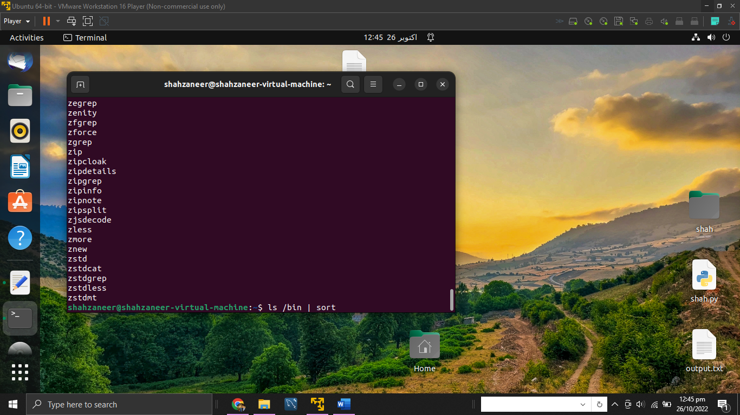

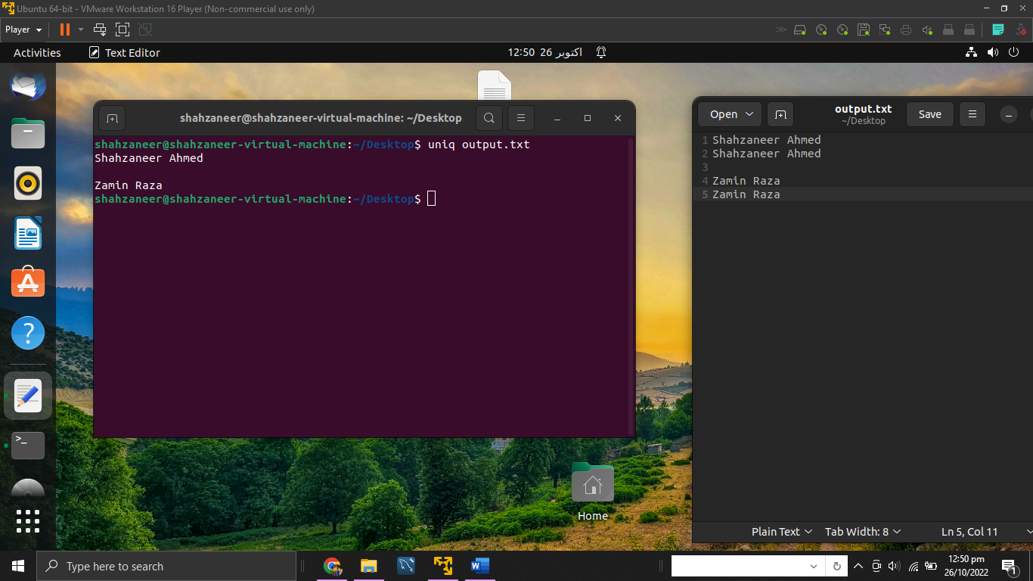

// Task 2

Use head and tail to print lines in a particular range in a file.

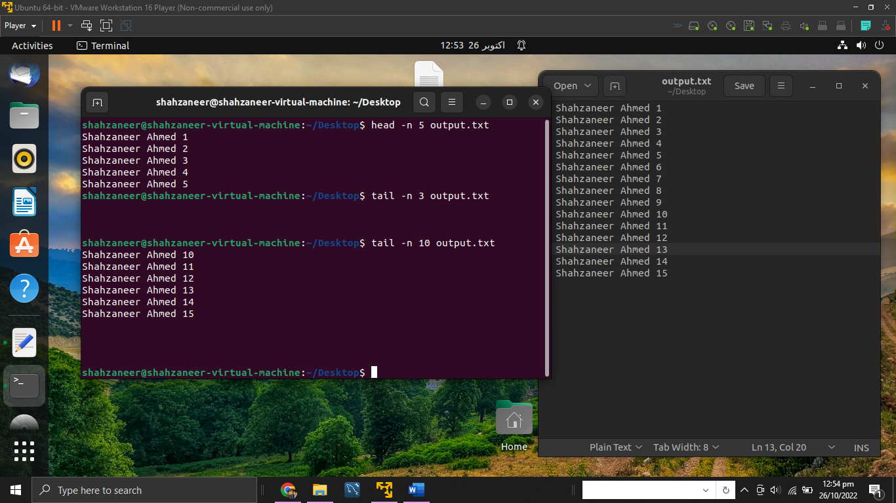

// Task 3

Use ls and find to list and print all lines matching a particular pattern in matching files.

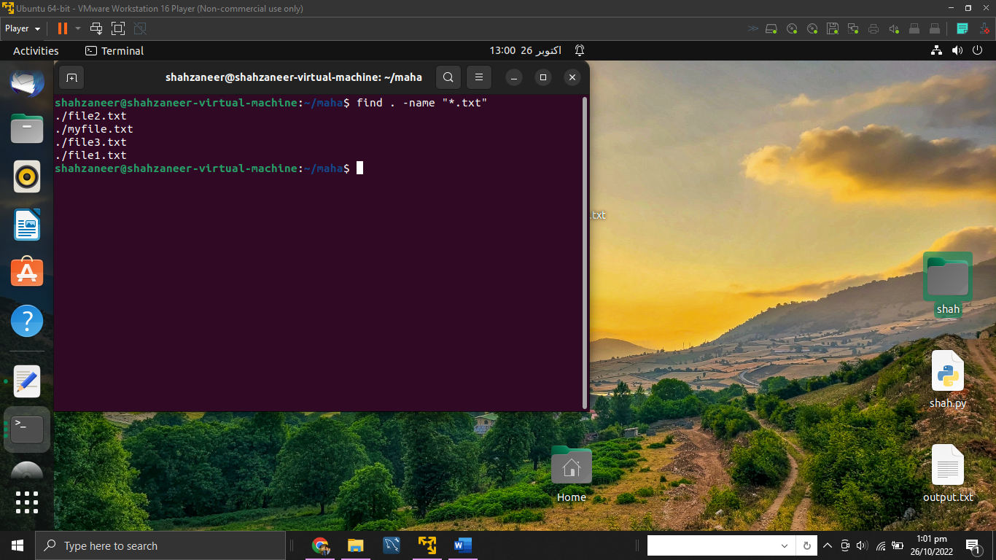

// Task 4

Use cat, grep, tee and wc command to read the particular entry from user and store in a file and print line count.

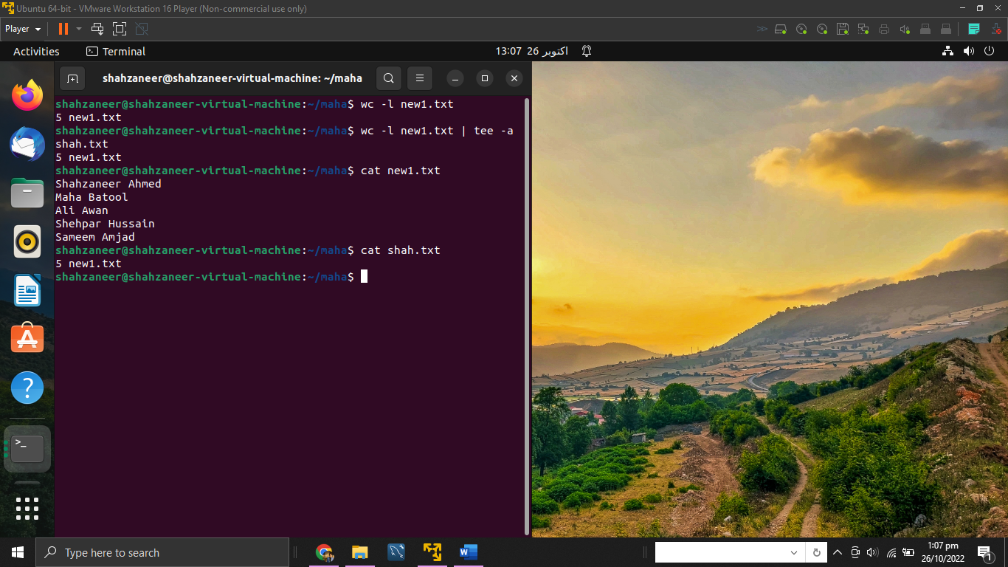

// Task 5

Pipes the output from the cat (concatenate) process into the sort process to produce sorted output, and then pipes the sorted output into the uniq process to eliminate duplicate records.

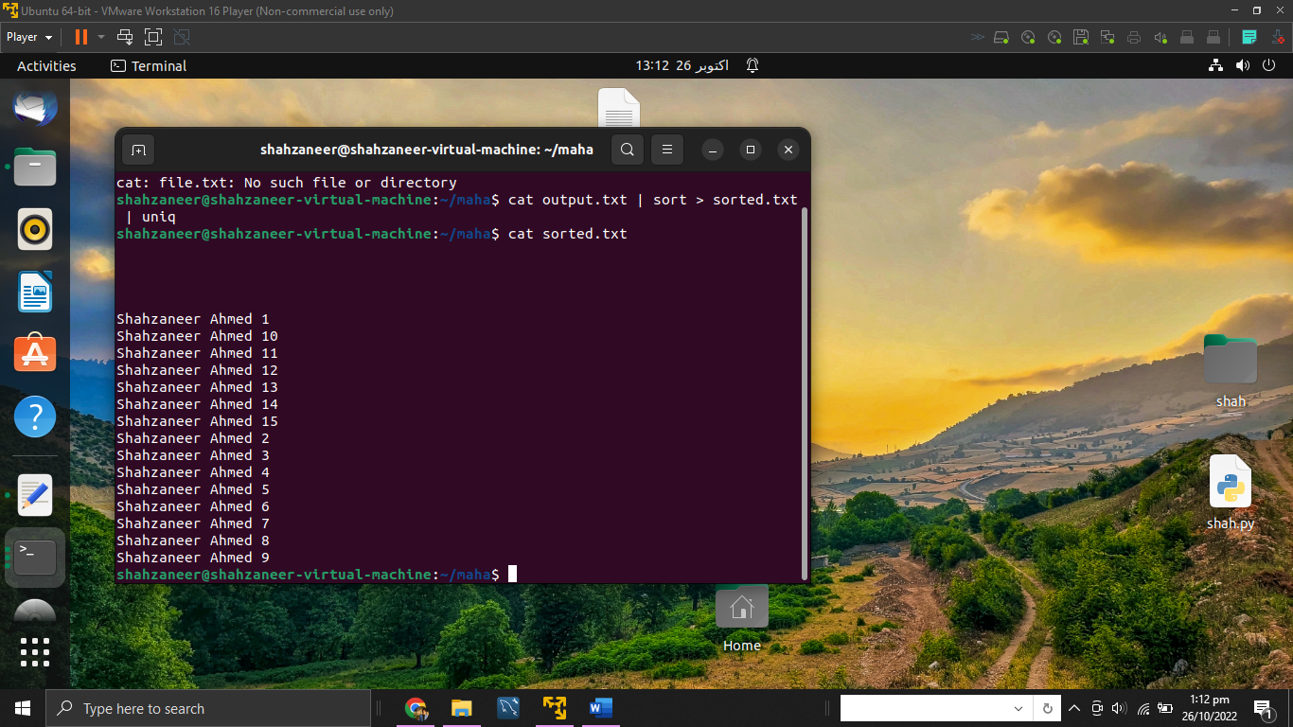

Lab 5

// Task 1

Change the program given in Activity 3 such that it accepts the input at command-line.

#include<iostream>

using namespace std;

int main ()

{

 int arr[10], n, i, max, min;

 cout << "Enter the size of the array : ";

 cin >> n;

 cout << "Enter the elements of the array : ";

 for (i = 0; i < n; i++){

    cin >> arr[i];

 }

    max = arr[0];

for (i = 0; i < n; i++){

    if (max < arr[i])

    max = arr[i];

}

    min = arr[0];

for (i = 0; i < n; i++){

    if (min > arr[i])

    min = arr[i];

}

    cout << "Largest element : " << max;

    cout<< "Smallest element : " << min;

    return 0;

}

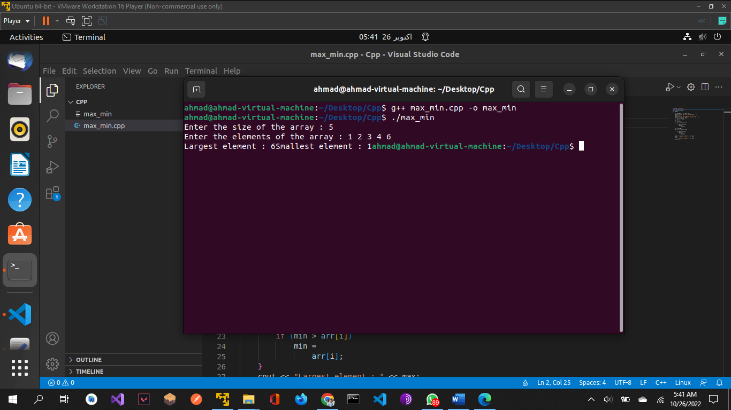

// Task 2

Write a C++ program that accepts a number as input and find whether it is a palindrome or not

#include<iostream>

#include<string>

using namespace std;

int main(){

int number;

cout<<"Enter a number to check is a number is palindrome or not";

cin>>number;

int num,count;

count=0;

num=number;

string charnum;

stringstream ss;

ss<<number;

ss>>charnum;

while(num!=0){

num=num/10;

count++;

}

bool gg=true;

if(count%2==1){

int i = 0;

count--;

int half = count/2;

while(i!=half){

if(charnum.at(i)!=charnum.at(count-i)){

gg=false;

}

i++;

}

}

else{

int i =0;

count--;

int half = count/2;

while(i!=half+1){

if(charnum.at(i)!=charnum.at(count-i)){

gg=false;

}

i++;

}

}

if(gg){

cout<<"Yes the number is palindrome”;

}

else{

cout<<"NO the number is not a palindrome";

}}

Lab 6

// Task 1

Write a C++ program that creates an array of size 1000 and populates it with random integers between 1 and 100. Now, it creates two child processes. The first child process finds how many prime numbers are there among first 500 number while the second child process finds the number of prime numbers among the remaining 500 numbers

#include<iostream>

#include<stdio.h>

#include<stdlib.h>

#include<unistd.h>

#include<sys/wait.h>

#include<cstdlib>

using namespace std;

int main(){

int arr[1000];

for(int i = 0 ; i<1000 ; i++ ){

arr[i]=(rand()%100);

}

int ch1 = fork();

if(ch1!=0){

cout<<"I am the parent process of first child with pid: "<<getpid()<<endl;

}

else{

int count=0;

for(int i = 0 ; i<499 ; i++){

int j =9;

while(j!=1){

if(arr[i]%j==0){

count++;

break;

}

j--;

}

}

cout<<"I am the first child process with pid"<<getpid()<<endl;

cout<<"Count of prime numbers in first half is "<<(500-count)<<endl;

exit(0);

}

int ch2 = fork();

if(ch2!=0){

cout<<"I am the parent of the second child process with pid :"<<getpid()<<endl;

}

else{

int count = 0;

for(int i = 499 ; i<1000 ; i++){

int j =9;

while(j!=1){

if(arr[i]%j==0){

count++;

break;

}

j--;

}

}

cout<<"I am the second child process with pid"<<getpid()<<endl;

cout<<"Count of prime numbers in second half is "<<(500-count)<<endl;

exit(0);

}

}